Banogue NS


Wellbeing Policy

1. Introduction & Rationale

The Department of Education’s Wellbeing Policy Statement and Framework for Practice (2018–2023, revised 2019) places wellbeing at the core of a school’s ethos and requires schools to embed a Wellbeing Promotion Process through the School Self-Evaluation (SSE) cycle.
Wellbeing is understood in a broad, holistic sense, encompassing the physical, mental, emotional, social, and spiritual dimensions of pupils, staff, families and the wider school community.
A primary school offers a unique environment in which children spend much of their day — it is therefore well placed to nurture wellbeing, resilience, positive relationships, and life skills. The Well-Being in Primary Schools guidelines (Dept of Education) also emphasise that schools should adopt a “whole-school” approach.
This policy outlines our schools commitment to embedding wellbeing in all aspects of school life, ensuring that each pupil is supported to realise their potential, develop resilience, maintain good health, and feel a strong sense of belonging.

Definition of Wellbeing

The following definition of wellbeing aims to take account of its multi-dimensional nature (World Health Organisation (WHO, 2001)
“Wellbeing is present when a person realises their potential, is resilient in dealing with the normal stresses of their life, takes care of their physical wellbeing and has a sense of purpose, connection and belonging to a wider community. It is a fluid way of being and needs nurturing throughout life.”

2. Vision & Aims
Vision
At Banogue NS, we seek to foster an environment in which every child, staff member, and family feels valued, connected, supported and empowered to flourish.
Aims
We aim to:
- Promote the physical, emotional, social, and mental health of pupils and staff.
- Support children to develop resilience, self-awareness, self-management, and social skills.
- Foster positive, respectful relationships across the school community.
- Ensure that the “voice” of children is heard in decisions affecting their wellbeing.
- Use evidence-informed practices to plan, monitor, evaluate, and review wellbeing initiatives.
- Provide appropriate support and intervention for children who may be vulnerable or at risk.
- Promote a culture of respect, inclusion, fairness, and empathy.
- Engage parents, guardians, and community partners in supporting wellbeing.

3. Guiding Principles
This policy is underpinned by these principles (as drawn from the national framework)
- Child/young person-centred: The needs and best interests of children are central, including listening to their voice and fostering belonging.
- Equitable, fair and inclusive: All pupils should have access to supports, tailored to their needs and context.
- Evidence-informed: Practice is to be informed by research, evaluation, and feedback.
- Outcomes-focused: Emphasis is placed on measuring and reflecting on impact, not merely doing activities.
- Partnership/Collaboration: Wellbeing is a shared responsibility — between school leadership, staff, pupils, families, external agencies.
Documents which have informed our Wellbeing Policy planning:
● Wellbeing Policy Statement and Framework for Practice (DES, 2018)
● Schools for Health in Ireland: Framework for Developing a Health Promoting School (HSE, 2013)
● Looking at Our School: A Quality Framework for Primary Schools (DES, Inspectorate, 2016)
● Well-Being in Primary Schools Guidelines for Mental Health Promotion (DES, DOH & HSE, 2015)

Wellbeing Policy Statement and Framework for Practice
The Department’s Wellbeing Policy Statement and Framework for Practice assists schools in ensuring that wellbeing promotion is embedded within the school’s existing practice. The school’s review and development process using the Wellbeing Policy Statement and Framework for Practice provides guidance and practical resources to assist in the further enhancement of whole school approaches to wellbeing promotion. The Wellbeing Framework for Practice outlines:
1. Key areas of wellbeing in education
2. Indicators of success in each of these areas
3. Statements of effective practice to guide schools
4. Suite of online wellbeing resources
Schools for Health in Ireland: Framework for Developing a Health Promoting School
The Health Promoting Schools process provides a comprehensive approach for school selfevaluation in:
• Environment (physical & social)
• Curriculum, Teaching and Learning
• School Policy and Planning
• Partnerships (family and community links)
A health promoting schools approach is a way of thinking and working that is adopted by all in the school to make it the best possible place to learn, work and play (Queensland, 2005).
Looking at Our School: A Quality Framework for Primary Schools
Looking at Our School articulates the Department’s holistic view of learning in schools. The framework sees wellbeing as both an enabler of learning and an outcome of learning. It emphasises the need for children and young people to develop a broad range of skills, competencies and values that enable active citizenship, lifelong learning and personal wellbeing. The framework asserts that in providing good quality learning experiences, teachers need to also consider children and young people’s wellbeing and that effective school leadership and management involves creating and maintaining a positive, secure and healthy culture where the holistic development of all children and young people is enabled. Looking at Our School also provides a coherent approach to improving outcomes and experiences for all children and young people. It is used to assist schools in embedding self-evaluation processes and reflective practices and it provides a structure for implementing new initiatives. The domains and standards of Looking at Our School can therefore support schools in promoting and enhancing the wellbeing of all members of the school community
4. Scope & Who It Applies To
This policy applies to:
- All pupils in Banogue NS
- All staff in Banogue NS (teaching, administrative, ancillary)
- School management / Board of Management
- Parents, guardians, and families
- Visiting personnel, external facilitators, and community partners working within the school
5. Wellbeing Promotion: A Whole-School Approach
We adopt a multi-component, whole-school approach to wellbeing, embedding it into all facets of school life in Banogue NS. According to the national framework, there are four key areas of focus: We will integrate wellbeing considerations in all school policies (e.g. discipline, homework, assessment) and across transitions (e.g. infant-juniors, primary to post-primary).
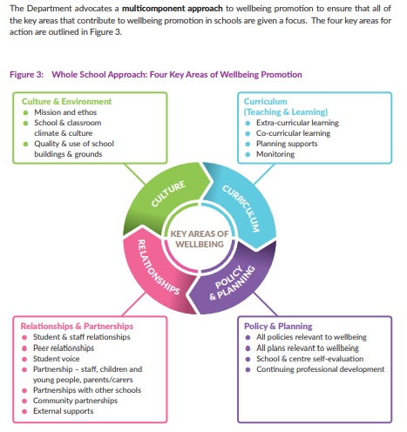
School Based Initiatives that promote wellbeing
Banogue NS implements a number of programmes and initiatives throughout daily school life that support the well-being of our pupils; this list is not exhaustive;
- Playful Learning Experiences: Playful learning aims to stimulate the construction of new knowledge and skills by letting students wonder, experiment, fail, take risks, construct, and reflect critically on the content and their learning experience. Successfully integrating playful learning into teaching involves creating an environment where both teachers and children can engage with content in an interactive, enjoyable and hands-on way. Junior and Senior Infants will participate in Freeplay each day.
- Universal Design for Learning: Teachers will provide for a Universal Design of Learning in preparation for the children in their class.
- Project based learning from 1st class to 6th class
- SPHE Curriculum
- Friends for Life
- Weaving Wellbeing
- Amber Flag Programme and Amber Flag Week
- Active Schools Programme and Active Schools Week
- Movement Breaks throughout the day for all children, with targeted ones for children with additional needs.
- Mindfulness and Breathing exercises throughout the day in every classroom
- Conflict Resolution - Staff CPD in Conflict Resolution
- School Committees to give students a voice– School Council, Green Schools Committee, Active Flag Committee
- Outdoor Learning - The school has developed the outdoor space recently with the addition of a sensory school path around the field, with activities and sensory equipment located along the path. This includes a trampoline, trees, willow den, climbing frame, outdoor log area, musical chimes etc.
- External teachers for different strands of PE to promote active living e.g. GAA, rugby, basketball etc.
- Voluntary school staff coaches for GAA teams after school
- School subsidised swimming lessons – 6 week block for all pupils
- Healthy Eating Policy
- Whole-school assemblies and Masses
- Themed Weeks (e.g. Maths Week, Science Week, Engineers Week, Book Week, etc)
- Promoting the Arts – whole-school musical, infant plays, purchase of school instruments, Whole school Music programme Dabbledoo, School Band from Senior Infants to 6th
- After School Clubs -Ógras, Irish Dancing
- Laya Supertroopers 3rd-6th
- Irish Heart Foundation Junior Infants-6th
- Commmunity and Parent Events e.g Grandparents Day, School Sports Day, Christmas Show etc.
- Parental Involvement in School Life e.g Parents Council, Communion events etc.
- .Communicating with National Council for Special Education (NCSE) to gain SNA access for pupils
- Education Welfare Officer – support for pupils with poor attendance
- Links with HSE personnel e.g. Primary Care Team, Child Disability Network Team, Assessment of Need Team
- The Continuum of Support Model offers a flexible framework within which schools can address all educational needs, including wellbeing needs.

6. Structure for Implementation & Responsibilities
Wellbeing Leadership & Coordination
- Board of Management – ensures policy implementation, allocates resources, oversees review
- The Principal has overall responsibility for implementing the Wellbeing Policy.
- An APII post holder has the responsibility of Staff Wellbeing Officer and is responsible for arranging the celebration of special occasions for staff members e.g birthdays, weddings etc.

Staff Responsibilities
- All staff will engage in professional development to build capacity in wellbeing promotion, mental health awareness, social-emotional learning.
- Teachers will model positive behaviour, emotional literacy, and relationships, and integrate wellbeing strategies into their classes.
- Staff will monitor students’ wellbeing, identify those in need, and refer as per agreed procedures.
Pupil Voice & Participation
- The voices of pupils will be actively included (through class discussions, surveys, focus groups) in planning wellbeing activities.
- A Student Council may operate to give students a role in influencing policy, activities, or improvements.
Parental / Family Partnership
- Parents/guardians will be informed of the Wellbeing Policy and invited to contribute their opinions (e.g. through surveys).
- The school will provide information, resources, and signposting to external support services for families.

Partnership with External Agencies
- The school will collaborate with the National Educational Psychological Service (NEPS), HSE, mental health services, community groups, etc.They may provide specialist support and resources when required

7. Identification, Support & Referral
Continuum of Support
Currently, Wellbeing in our school is operating on a continuum of support with
- Support for All
- Support for Some
- Support for a Few
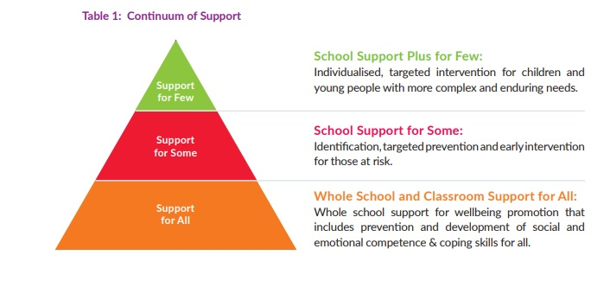

Early Identification & Monitoring
- Staff will be alert to behavioural, emotional, social or academic indicators of distress or wellbeing risk.
- Wellbeing screening tools, surveys, or checklists (e.g. at the start/mid/end of year) may be used.
- The SET/Principal will maintain a confidential register of pupils receiving additional supports (with relevant consent).
Referral Pathways
- Clear procedures for internal referral (class teacher → support team → principal).
- Clear criteria and procedures for referral to external services (e.g. NEPS, HSE mental health, counselling).
- Parental/guardian communication and consent protocols will be respected at all times.
Crisis / Critical Incidents
- The school’s critical incident policy will be aligned with wellbeing supports (e.g. bereavement, trauma).
- Staff will receive training in responding to distressed pupils, safeguarding, and supporting post-crisis recovery.

8. Wellbeing Promotion in Practice

The Indicators of Success are further expanded upon in the statements of effective practice which appear as Appendix A, which provide a set of standards for wellbeing practices across the Continuum of Support at the whole school preventative level (Support for All) and also at the targeted and more individualised levels (Support for Some and Few).

Support for All: a process of prevention, effective mainstream teaching, early identification and intervention for children who are showing mild or transient signs of difficulty. School support for ALL is embedded within every classroom and part of a whole school approach to mental health promotion.

- Banogue NS prioritises regular review and development of policies relating to wellbeing such as child safeguarding,anti-bullying and critical incidents.

- The voices of pupils, parents and staff inform the development, review and updating of many school policies through the use of surveys etc.

- Our mission statement contains the sentence Banogue NS endeavors “ That children will have received a well-rounded education, be literate and numerate, emotionally developed, be concerned citizens, be caring, aware and sensitive to their fellow human beings.”

- The staff do a “Meet and Greet” at the main entrance each morning to ensure a warm and welcoming arrival for children and parents to the school.

- The school building, grounds, classrooms, bathrooms and work spaces are well maintained and appropriately furnished, creating a welcoming, safe and warm environment.

- Each classroom has a “safe space” for children in the classroom to take a break when necessary. E.g Calm corner, sensory tent, zen den etc.

- Children are taught about the “Zones of Regulation”. They are encouraged to identify the feelings in each zone and develop a skillset to help them regulate their emotions.

- The indoor space displays the work, talents and accomplishments of children and young people.

- School leaders and management understand the link between physical activity and wellbeing and facilitate physical activity and movement breaks within the school environment.

- Our school has a two year SPHE plan which ensures all strands and strand units are covered during the two year cycle and we also have a Relationships and Sexuality Education Policy. We follow the Making the Links scope. This is a guide to using materials from the Walk Tall Programme, the Relationships and Sexuality Education Programme (RSE) and the Stay Safe Programme

- Outdoor Learning - The school has developed the outdoor space recently with the addition of a sensory school path around the field, with activities and sensory equipment located along the path. This includes a trampoline, trees, willow den, climbing frame, outdoor log area, musical chimes etc.

- We have a Students Council to ensure that the voices of children are heard and we encourage teachers to seek pupil’s opinions on their learning throughout our classrooms.

- School leaders and management acknowledge the importance of staff wellbeing and promote this in a variety of ways including recognition of the value of staff contribution and their work.

- School leaders and management ensure that appropriate support mechanisms are put in place for staff wellbeing and details of the Employee Assistance Service and other relevant supports are made available to staff.

- Management supports staff to help them sustain their own mental health and well-being and attempts to avoid overloading staff with new initiatives in any given year.

- Our school uses the Education Passport (NCCA) for pupils transitioning to post primary school and we have a transition programme for our 6th class children moving to secondary school.

- We have built good relationships with Banogue Community Creche and we plan for successful transitions of the majority of our incoming Junior Infants. We facilitate an Infant Storytime at the end of June and also, an Infant Welcoming Day where incoming Junior Infants pupils are invited in for a half day in June.

- We prioritise fostering effective partnerships with parents and we have developed relationships with the wider school community including sporting organisations. We also liaise with appropriate external agencies and services e.g. NEPS psychologists, NCSE special education needs organisers, HSE health promotion and improvement division, primary care teams,and Tusla child and family services.

- Some members of staff have received training in the Friends for Life Programme to develop resilience in our children.

- Banogue NS has a Healthy Eating policy and, if parents wish, they can order healthy school lunches through Mint Catering company which delivers hot lunches to the school.

- In P.E., we are developing physically literate children through the lens of Fundamental Movement Skills.

- Children of all abilities from Senior Infants-6th Class are welcome to join the school band.

- There are a number of After-school Clubs; including School Band, Ógras, Irish Dancing and Gaelic, hurling and soccer training.

- We promote the 4 pillars of Inclusion, Kindness, Respect and Fun in our classrooms and at break times.

- We have a buddy step on the yard and encourage the children to look out for each other and include everyone in play.

- There is a positive approach to discipline where issues are resolved with care, respect and consistency using the restorative practice model.

- Our recent engagement with national Anti-bullying initiatives resulted in a school-wide project and display to reflect the motto of “No to Bullying, Yes to Kindness”.

- We apply for the Pieta House Amber Flag award each year. This is an initiative run by Pieta House which recognises the individual efforts of primary schools to create healthy, inclusive environments that support mental wellbeing. We hold an Amber Flag Week each year where we focus on promoting wellbeing through initiatives like peer reading, morning disco, art competitions.

- We also participate in Active Schools Flag as we recognise the importance of sports and movement for Mental Health and wellbeing.

Support for Some: embedded in a whole school approach and focuses on identifying the small number of young people who are at risk of developing unhealthy patterns of behaviour or those who are already showing early behavioural signs of mental health difficulties

- Some students get targeted movement breaks from the classroom which is facilitated by a class teacher or SNA

- Staff and pupils are welcoming and inclusive of those from cultural backgrounds and those with additional needs.

- Teachers design and prepare for differentiated teaching methods and assessment of learning outcomes for pupils at risk or with additional and/or complex needs so that they experience a sense of achievement.

- The school deploys resources based on individual learning, behavioural, social and emotional needs under the Special Education Teaching Allocation model.

- School-based information is used, in conjunction with reports from external professionals, to set guidelines and recommendations for individualised supports for children and young people with additional needs.

- A student support file is used to plan, record and review progress.

- Classroom Support plans are drawn up by the class teacher for children who receive additional support within the classroom.

- Individual behaviour plans will be drawn up for children who display behaviours of concern. These plans will be drawn up in collaboration with parents, class teachers, Special Education Teachers (SETs) and the Principal and discussed/reviewed regularly, at least termly.

- We use the NEPs Continuum of Support model for children which enables us to identify students’ educational needs, to include academic, social and emotional needs, as well as needs associated with physical, sensory, language and communication difficulties. The Continuum of Support enables us to identify and respond to needs in a flexible way. This means that needs can be responded to as early as possible and pupils with the greatest level of need have access to the greatest levels of support. SETs provide supports in Language, Literacy and Maths but also look after other needs through, for example, social skills groups, nurture sessions and emotional literacy.

- Our team of SNAs work in collaboration with teachers and parents to support children with additional needs. Personal Pupil Profiles are drawn up for these children which identify the challenges, establish targets and put in place strategies to achieve the targets. SNAs have access to the Sensory room/areas (sensory path, outside sensory play space) to meet the needs of these children.

- A Summer Programme is available to children with complex additional needs and those at risk of educational disadvantage.

- For a small minority of pupils, attendance incentives are in place, punctuality is deprioritised and attendance is encouraged/supported at any time of the morning.
·
- The school demonstrates commitment to identifying, including and providing targeted supports for children and young people experiencing barriers and challenges to wellbeing and learning.

Support for a Few: a particular focus on putting interventions in place for children with more complex and enduring needs.

- A small number of children require intensive individualised programmes. These children are usually identified when interventions at School Support for Some stage have been insufficient to meet their needs.

- We have 2 sensory rooms in our school which are available to children on a regular basis and to any pupil in times of need as identified by the class teacher.

- Befriending and buddy systems are in place for some pupils who require support to interact with peers.

- Specialist technology is acquired as necessary.

- We have access to advice and support from a NEPS psychologist, and all decisions in relation to pupils requiring significant supports are made in consultation with staff and parents.

- We have 2 SETs (1 Fulltime and 1 shared) and 8 SNAs who are highly committed to looking after the welfare of the pupils in their care and who regularly show great flexibility as required.
·
- We have an extremely supportive Board of Management which provides funding for assessments urgently required for a minority of pupils but not available to them through public channels and/or in a timely fashion.

9. Professional Development & Staff Wellbeing
Continuous Professional Development (CPD)
- The school will plan and provide CPD in areas such as social-emotional learning, trauma-informed practice, mental health first aid, mindfulness, etc.
- Staff will be encouraged to participate in wellbeing networks, communities of practice, peer support, reflective practices.

Wellbeing of Staff
- Leadership will monitor staff workload, promote healthy boundaries, and encourage a supportive working culture.
- Support for the wellbeing of staff is also an essential element in wellbeing promotion, and crucial to sustaining teacher/staff engagement, enthusiasm and the ability to model resilience. It builds staff capacity to cope with challenges and adapt to change, and creates conditions to support and motivate staff to be effective. Banogue NS is a safe and supportive environment for staff members. All staff members are supported in maintaining their personal health and wellbeing. Our staff benefit from reflecting on our own wellbeing and general attitudes to mental health.
- All staff are made aware of supports for teacher wellbeing and that individual teachers requiring additional support at a particular time may access the Employee Assistance Service (EAS). Posters are displayed in the staffroom and toilets.

10. Monitoring, Review & Evaluation
Wellbeing Promotion Process within SSE
- The Wellbeing Policy will be integrated into the School Self-Evaluation (SSE) process, with defined targets, strategies, and indicators of success.
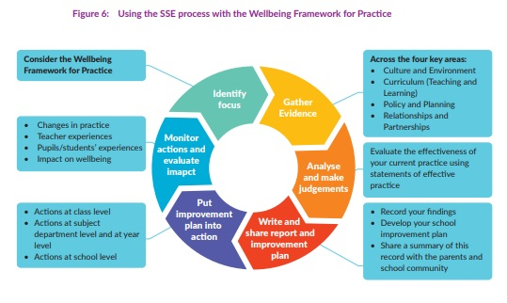
- Schools are required to conduct regular cycles of review and improvement of wellbeing practice. See Framework below

Indicators & Success Measures
We will collect data (qualitative and quantitative) such as:
- Pupil, staff, parent wellbeing surveys
- Attendance, behaviour, retention, exclusions data
- Uptake and impact of wellbeing initiatives/
- Feedback from focus groups , pupil voice and student council
- Case studies or individual progress reports
Indicators of Success
In Banogue NS, we use the Wellbeing Indicators of Success to identify our strengths and targets for improvement, and to actively monitor our progress and outcomes in relation to wellbeing promotion over time. We achieve this by accessing the opinions and views of all stakeholders throughout the process. The Wellbeing Indicators of Success, outlined in Table 5, are the broad outcomes to which the Department aspires and wants schools and centres for education to accomplish.
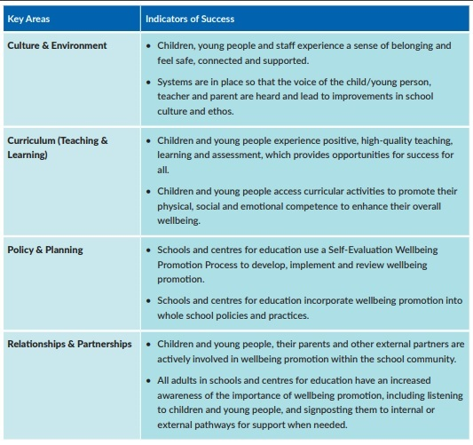
These Indicators of Success in the four key areas of Wellbeing are further expanded upon as statements of effective practice in the Wellbeing Framework for Practice (Appendix A) which will form the basis of the school’s self-reflective Wellbeing Promotion Process.
Statements of Effective Practice in each of the four key areas of Wellbeing Promotion describe practices operating competently and efficiently at the whole school preventative level (Support for All) and also at the more specialised and individual intervention levels (Support for Some and Few). This is a key reference tool which helps to standardise the approach to reviewing wellbeing promotion in schools and centres for education. It is envisaged that schools and centres for education will engage with the statements and adapt and develop the best practice items as they meet the needs in their own school community.
The statements of effective practice should enable school leaders and staff involved in internal and external evaluation to arrive at evidence-based evaluative judgements about the quality of aspects of provision. They will enable school leaders and staff to identify strengths and areas to target within the school system and therefore plan the next stage in the improvement journey.
Review Cycle
- The Wellbeing Policy will be formally reviewed every three years, or earlier if required (e.g. after a critical incident, legislative change).
- The review will engage all stakeholders: pupils, staff, parents, external partners.
- Progress will be measured using:
-Attendance, engagement, and behaviour data
-Pupil, staff, and parent surveys
-Feedback from school community and external agencies
-Review of SSE and School Improvement Plan targets
- A revised version will be ratified by Board of Management and communicated to all.
11. Resources & Budgeting
- The school will allocate a dedicated budget for wellbeing (materials, programmes, training, staff release).
- Facilities, such as quiet zones, sensory rooms or reflection corners, will be provided as possible.
- The school will maintain a directory of local external supports and referral services.
- Other resources include: Department of Education Wellbeing Policy Statement & Framework, NEPS and Oide wellbeing resources, HSE Health Promotion & Improvement supports, School-based wellbeing programmes and initiatives

12. Communication & Dissemination
- The policy will be published on the school website, and a summary given to all parents/guardians.
- All new staff and substitute teachers will receive induction in relation to this policy.
- Pupils will receive age-appropriate orientation on the wellbeing policy, via classroom discussion or assemblies.
- Wellbeing initiatives, successes, and feedback will be communicated regularly (newsletters, meetings, displays).

13. Policy Links & Related Documents
This policy should be read alongside (and aligned with) the school’s:
- Child Protection & Safeguarding Policy
- Anti-Bullying Policy
- Behaviour / Discipline Policy
- Critical Incident Plan
- SPHE / RSE / PE curricula policies
- Attendance Policy
- Inclusion / SEN Policy
- Health & Safety Policy
- Data Protection / Confidentiality policies

14. Ratification
The Wellbeing Policy for Banogue National School was ratified by:

__________________________ Chairperson Date: ______________

___________________________Principal Date: ______________

