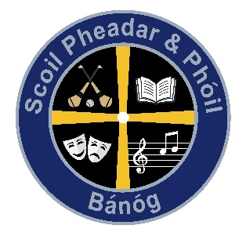

Banogue NS
ANNUAL ADMISSION NOTICE
in respect of admissions to the 2022 /2023 school year
-
Admission Policy and Application Form
A copy of the school’s Admission Policy and the Application Form for Admission for the 2022/ 2023 is available as follows: –
To download at: https://www.banoguens.com/
On request: By emailing banoguenationalschool@gmail.com or writing to: Banogue NS, Banogue ,Croom, Co. Limerick

Application and Decision Dates for admission to 2022/2023
The following are the dates applicable for admission to Junior Infants

The school will commence accepting applications for admission on | October 1st 2022
The school shall cease accepting applications for admission on | May 19th 2023
The date by which applicants will be notified of the decision on their application is | June 1st 2023
The period within which applicants must confirm acceptance of an offer of admission is | June 15th 2023
*Failure to accept an offer within the prescribed period above may result in the offer being withdrawn

Note: the school will consider and issue decisions on late applications in accordance with the school’s admission policy.

Special Class Application and Decision Dates for admission to Banogue NS
The following are the dates applicable for admission to the school’s Special Class which caters for children with [insert details of category/categories of SEN catered for in the class] -
The school will commence accepting applications for admission to the special class on | October 1st 2022
The school shall cease accepting applications for admission to the special class on | January 31st 2023
The date by which applicants will be notified of the decision on their application for admission to the special class is | February 17th 2023
The period within which applicants must confirm acceptance of an offer of admission is | 2 weeks
*Failure to accept an offer within the prescribed period above may result in the offer being withdrawn

Number of places being made available in [insert school year concerned]

The number of places being made available in junior infants | 24
The number of places being made available in the special class* catering for children with Autism is | 8

